**Robotic Arm Project**

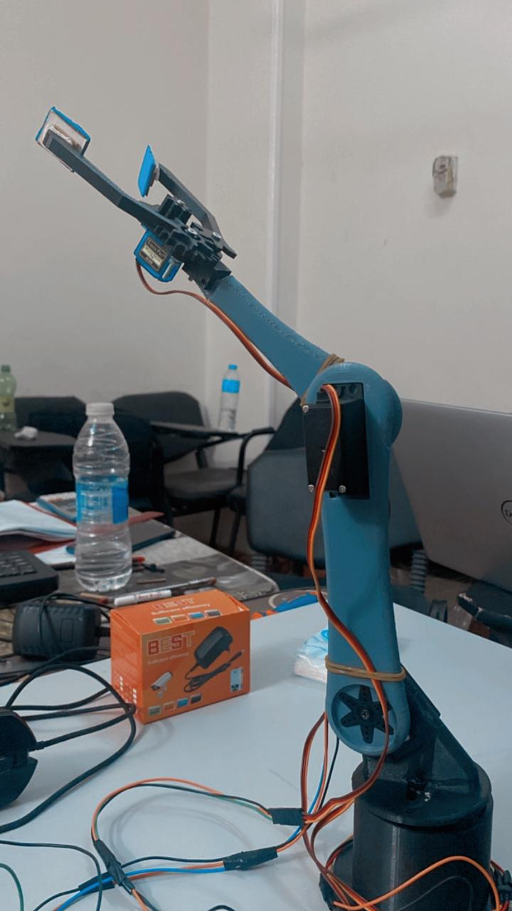

**UNDER THE SUPERVISION OF PROF : KHALED YOUSSIF**

**Team Members:**

* **Abd-Elrahman Ramadan Farg**
* **Rawan Wael El-sayed**
* **Bassam Khaled Muhmmed**
* **Maryam Reda El-Sayed**
* **Bavly Emil Tamer**
* **Mariam Emad Eldin**
* **Maged Micheal Seha**
* **Nevin Essam Helmy**
* **Mostafa Mohamed Tawfiq**
* **Yomna Saad Abd-EL Azeem**
* **Marwa Gamal Hendawy**
* **Youssef Ashraf Kamel**

**Content**

**Introduction**………………………………………………………………4

**Missions**…………………………………………………………………..5

**Description**……………………………………………………………5

**Modeling**………..……………………………………….…………….5

**Inverse** **kinematics** ………………………………………………………7

**Equations** …………………………………………………………….9

**Design** …………………………………………………………………….11

**Components** ..…………………………………………………………11

**Arduino** **code**……………………………….…………………………….13

**Reference** **and** **data** …….……………………………………………….16

* **Introduction**:

In the field of robotics, robotic arms play a pivotal role in automating tasks and increasing efficiency across various industries. This project delves into the design, development, and control of a robotic arm system, aiming to explore its capabilities and potential applications.

An automatic robotic arm is a mechanical device that imitates a human arm. It can be programmed and used in many industries. The arm consists of linked parts that can move and rotate, enabling it to do various tasks. Technology advancements like AI and machine learning have led to more advanced robotic arms. These arms can adapt and work autonomously. As a result, they are now widely used across industries and play a crucial role in automation systems. Robotics is the study, development, and use of robotic systems in production. The design of the robotic arm is created to assist various sectors in doing a job or work instead of employing human labor as manufacturing industry activities increase. Robots are typically used to carry out unpleasant, risky, excessively repetitive, and harmful activities.

Material handling, assembly, arc welding, resistance welding, machine tool load and unload functions, painting, spraying, and other tasks can all be done by robots. It is incredibly helpful since it does tasks with greater intellect, precision, and energy than humans do ,for instance, a robotic arm is frequently used in assembly or packaging lines to lift tiny things repeatedly, a task that would be too taxing for a person to perform for an extended length of time. The robotic arm can efficiently and quickly perform the light material lifting operation since it is not hampered by human weariness or health hazards.

**WHAT** **IS** **A** **ROBOTIC** **ARM?**

A robotic arm is a device constructed of linkages connected by appropriate joints so that it may move in space and with the degrees of freedom needed for the task at hand. Frequently, the robotic manipulator may be trained to do specific tasks. It is additionally referred to as anthropomorphic because of how close in function it is to a human hand.

* **Mission** **objectives**:

The objective of this project is to design and build a robotic arm that can be used in manufacturing industry. The robot arm is designed to be under the categorization of handling and picking robot arms. These robots can load and unload processing equipment, sort components from unorganized state to an organized one. For instance, the same sort must be arranged, stacked or placed into a tray as it moves down an assembly line.

**Description:**

To achieve the objective of the project and incorporate the additional updates. We have designed and constructed a highly robotic arm with 3 degrees of freedom which are controlled by motors under the influence of gravity .

The robot arm is localized on a fixed wooden surface with coordinates(0,0)in x and y axis, then with knowing orientation , angles and link length with the help of equations to move it from one position to another . it also controlled by joysticks .

The two motors controlled degrees of freedom provide the necessary precision and flexibility required for the arm to move In a 2D space with high accuracy and repeatability. The third degree of freedom , controlled by gravity, adds an additional level of flexibility and adaptability to the arm , allowing it to adjust to the shape and position to the cube

* **Modeling**

In order to consider the cost facture, toughness and required working time for specific operation there is need to improve the design to find out the perfect design of the arm. it is essential to understand which part of the geometry can be altered or removed with no influencing on the stress allocation results in the design. For that an initial was done and the region that is were far away from the highly-stressed regions were labelled. After that the useless features of geometry like screws and fillets that are far away from the pointed highly stress distributed regions were eliminated and the simple geometry was done. By observing the change in geometry, to ensure quality characteristics such as the robotic arm of mass moment of the center of inertia and gravity does not change significantly after simplification, in accordance with the nature and the original pattern.

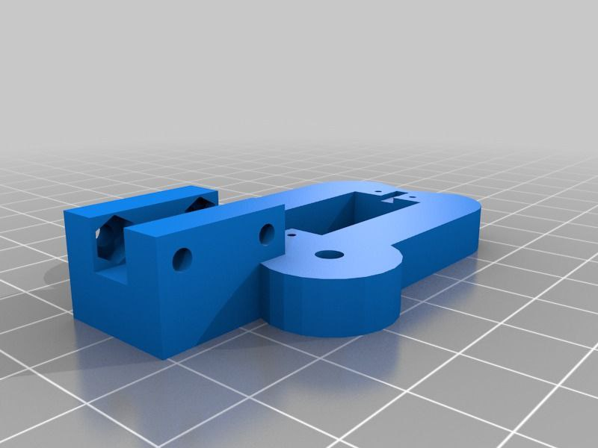 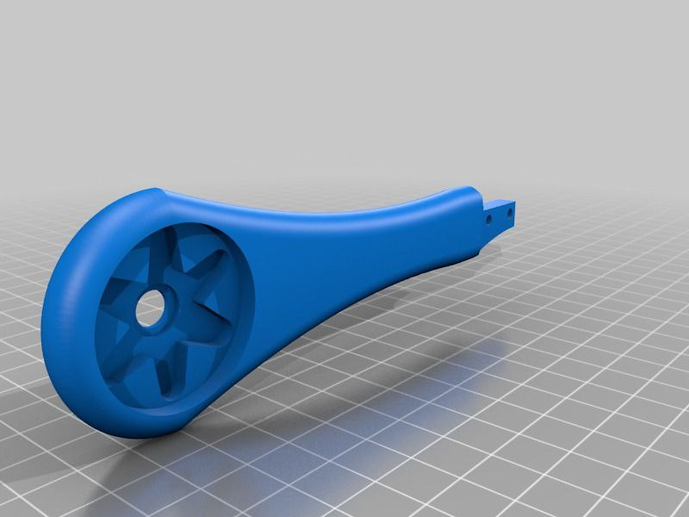

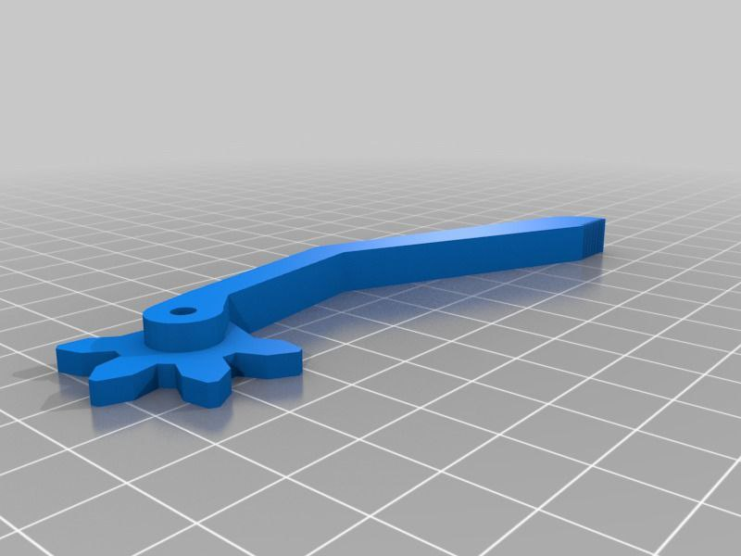 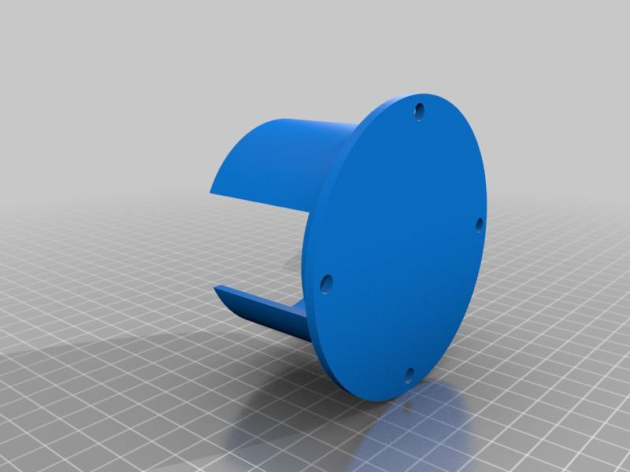

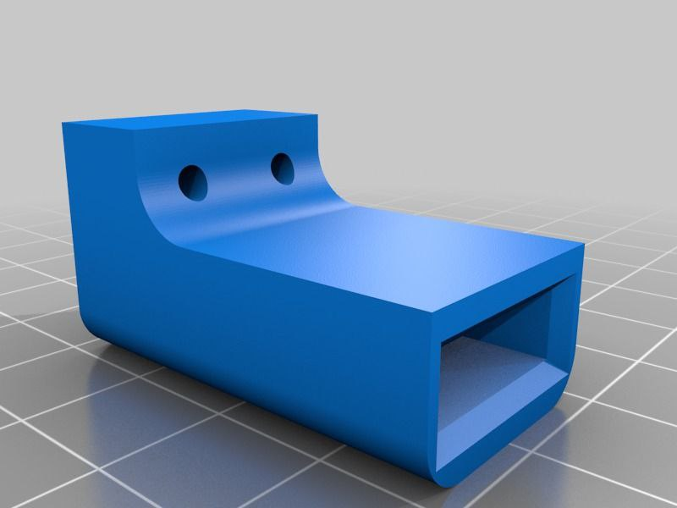 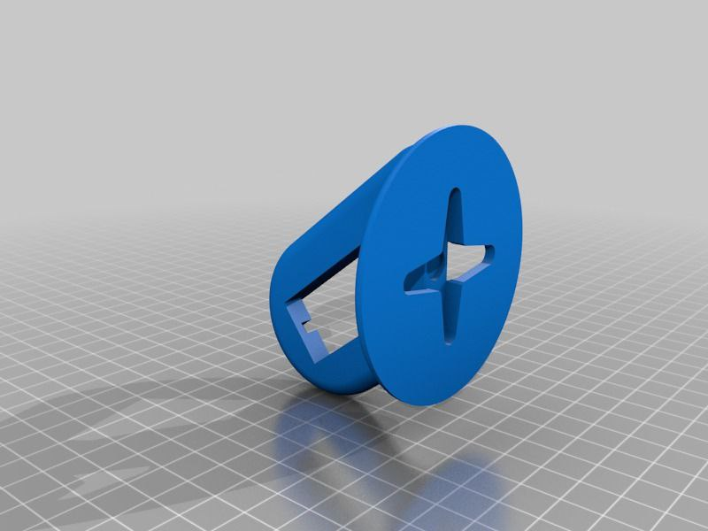

* **Inverse kinematics of robotic arm:**

Inverse kinematics is the process of determining the joint angles and positions required for a robotic arm to reach a desired end-effector position and orientation. This process involves solving a set of equations that relate the end-effector position and orientation to the joint angles of the robot.

The operation of inverse kinematics for a robotic arm typically involves the following steps:

1. Define the robot's kinematic model: This involves defining the relationship between the joint angles and positions of the robot's links, as well as the relationship between the end-effector position and orientation and the joint angles.

2. Specify the desired end-effector position and orientation: The user specifies the desired position and orientation that they want the end-effector of the robotic arm to reach.

3. Solve for joint angles: Using the kinematic model, equations are solved to determine the joint angles required for the robotic arm to reach the desired end-effector position and orientation.

4. Move the robotic arm: The calculated joint angles are then used to control each joint of the robotic arm, allowing it to move to the desired position and orientation.

5. Iterative refinement: In practice, inverse kinematics may not always result in perfect positioning due to factors such as mechanical limitations or inaccuracies in measurements. Therefore, iterative refinement techniques may be used to adjust the joint angles until they accurately reach the desired end-effector position and orientation.

Overall, inverse kinematics is an essential component of controlling robotic arms, allowing them to perform precise movements and tasks in various applications such as manufacturing, assembly, and research.

* **Equations**:

Torque calculation :

We have :

Weight of

L2 = 36 g

L3 = 19 g

Gripper = 25 g

So,

T servo1 = zero, cause it rotate about Z-axis

T servo2 = ((100/1000 × 46) + (80/1000 × 46/2)) = 6.44 kg.cm

T servo3 = ((100/1000 × 26) + (44/1000 × 26/2)) = 3.172 kg.cm

T servo4 = ((100/1000 × 7) + (25/1000 × 7/2)) = 0.7875 kg.cm

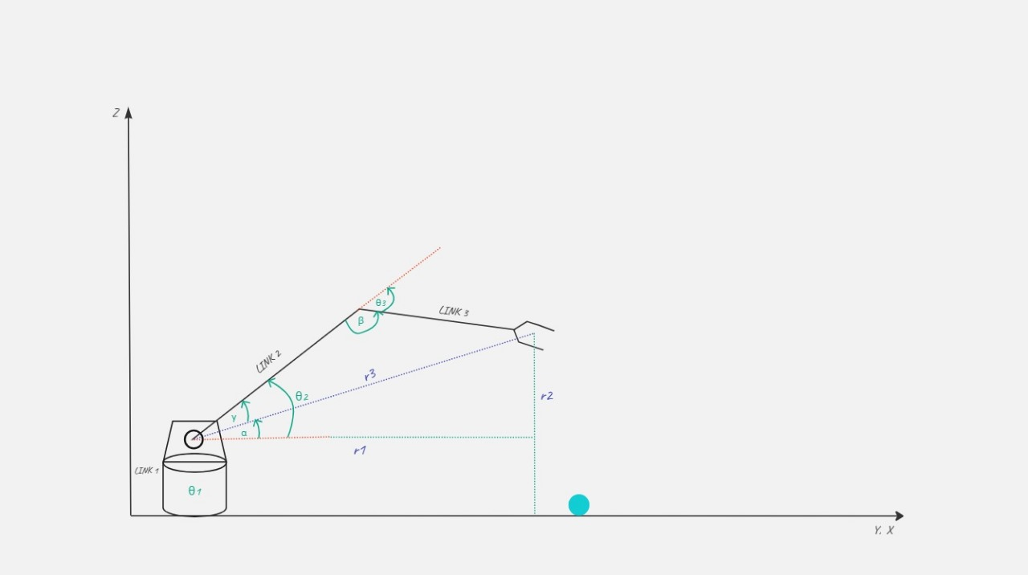

From the figure we got :

θ1 = Tan-1 (Yef/Xef) , r1 = √(Xef )²+ (Yef)² , r2 = Zef - L1

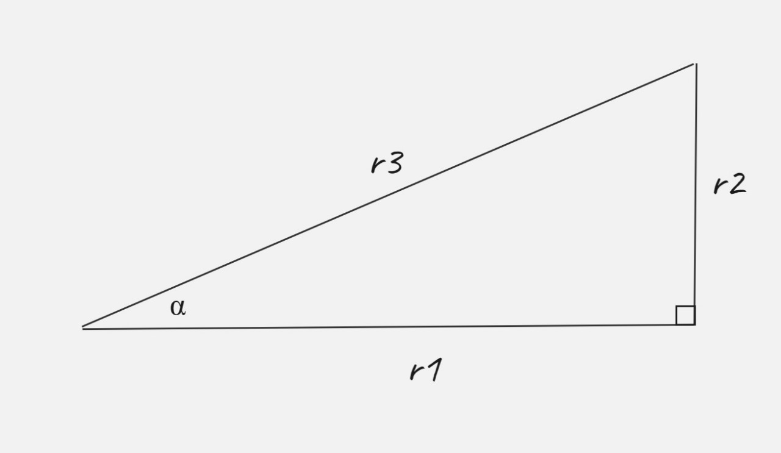

r3 = √(r1)²+(r2)² , α = tan-1 (r2/r1)

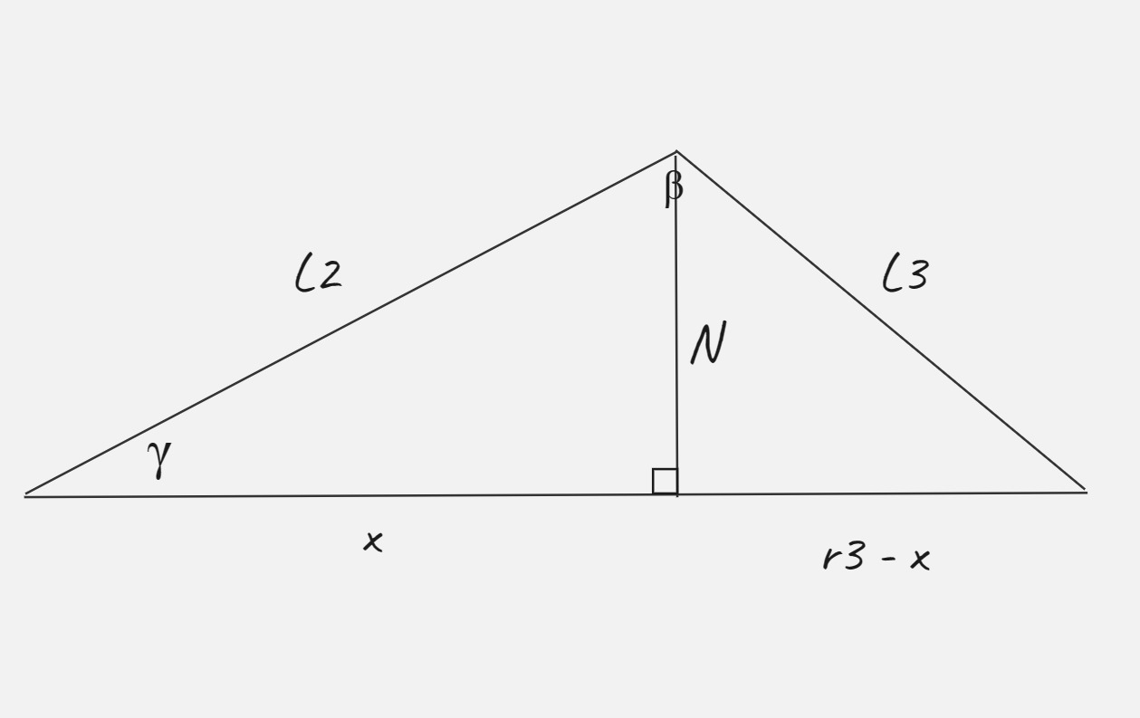

γ = tan-1 (N/X)

L2 = √(N)²+(X)²

L3 = √(N)²+(r3 - x)²

γ = Cos-1 ((L2)+(r3)-(L3) /2L2r3)

β = Cos-1 ((L2)+(L3)-(r3) / 2L2L3)

finally, we got:

θ2 = α + γ

θ3 = (π - β)

* **Design**:

The structure design of our robot arm consists of:

Fixed on a wooden surface. The arm consists of 3 links (3d printed ), 4 servo motors ,3 joints and gripper.

* The first one connects base with the first link at the first joint.
* The second one connects link with link in the second joint.

That’s provide the necessary movement and control

Materials needed for the mechanical part of the robot arm were supplied, and then  
the materials were drawn on SolidWorks in millimetric form. The mechanical part  
was assembled with these materials. Drawings of the mechanical part of the project  
are given in Figures.

* **Components:**
* 1 DC Power Adapter (6VDC _ 2A)
* 1 Breadboard 830 point (MP-102)
* 1 Mini micro servo motor 9G 180 degree
* 20 Jumper wire 10cm male to female (1 wire )
* 2 MG996R Servo motor 180 degree(11 Kg .cm metal Gears)
* 1 MG995
* Phcr M/M -30 cm male to male 1 jumper wire
* Bluetooth module HC05

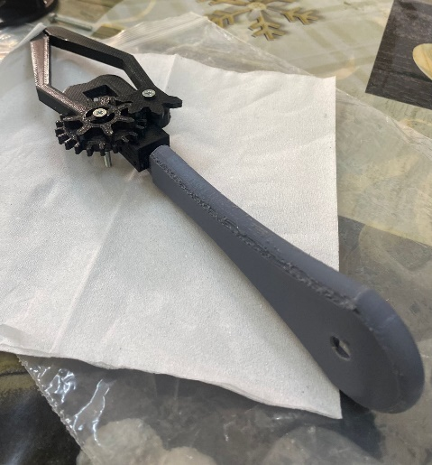

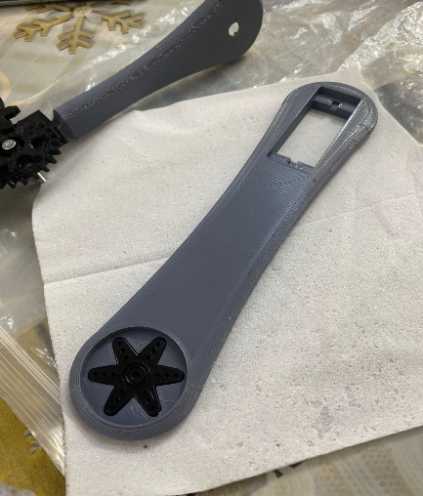 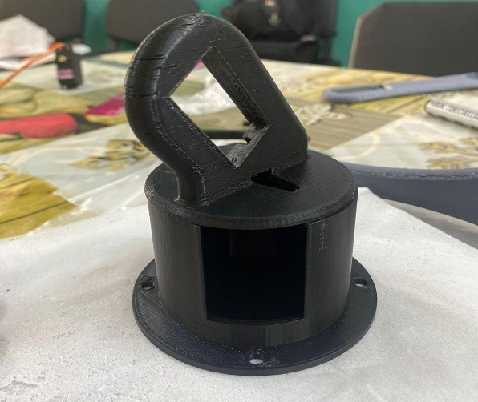

* **Arduino** **code**

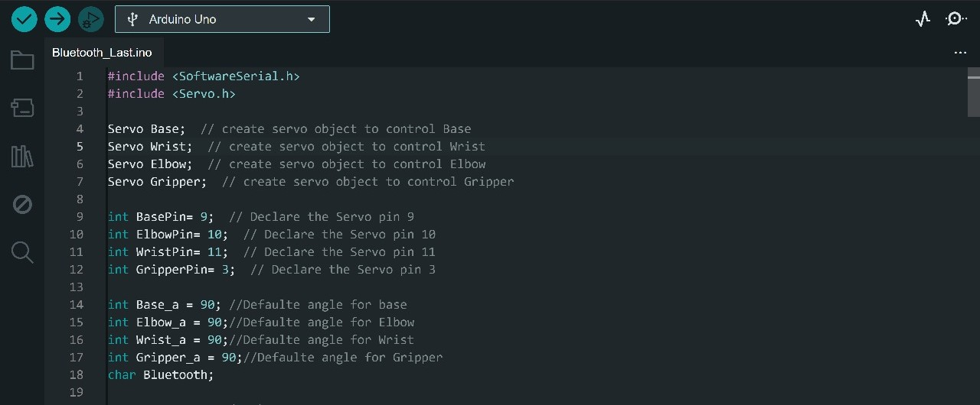

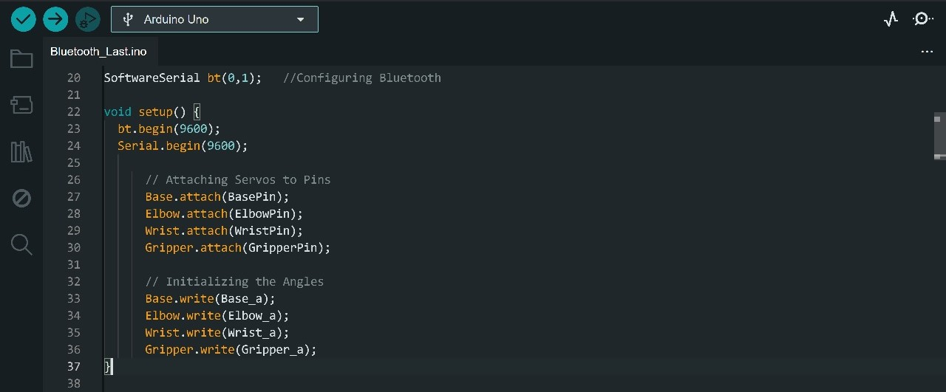

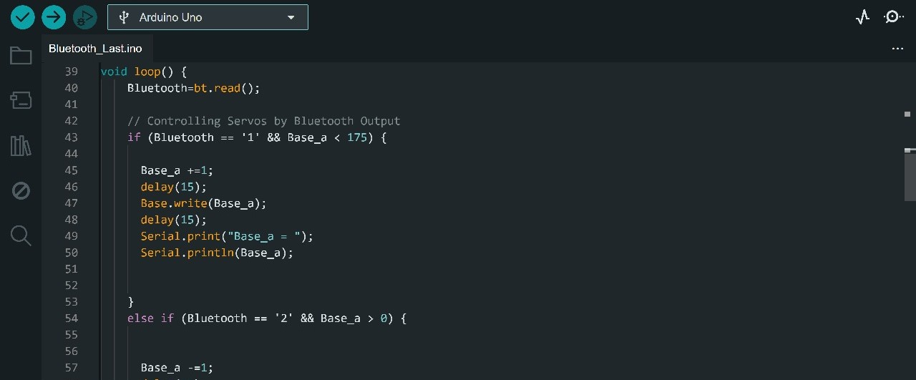

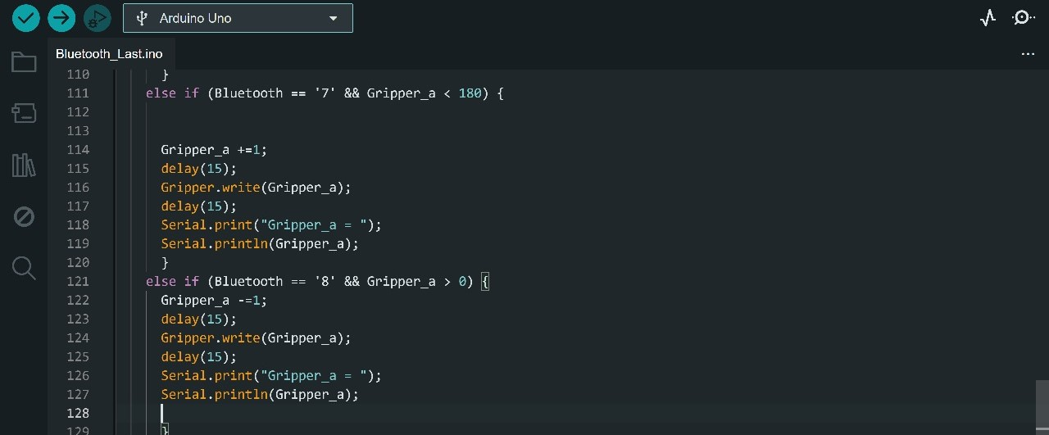

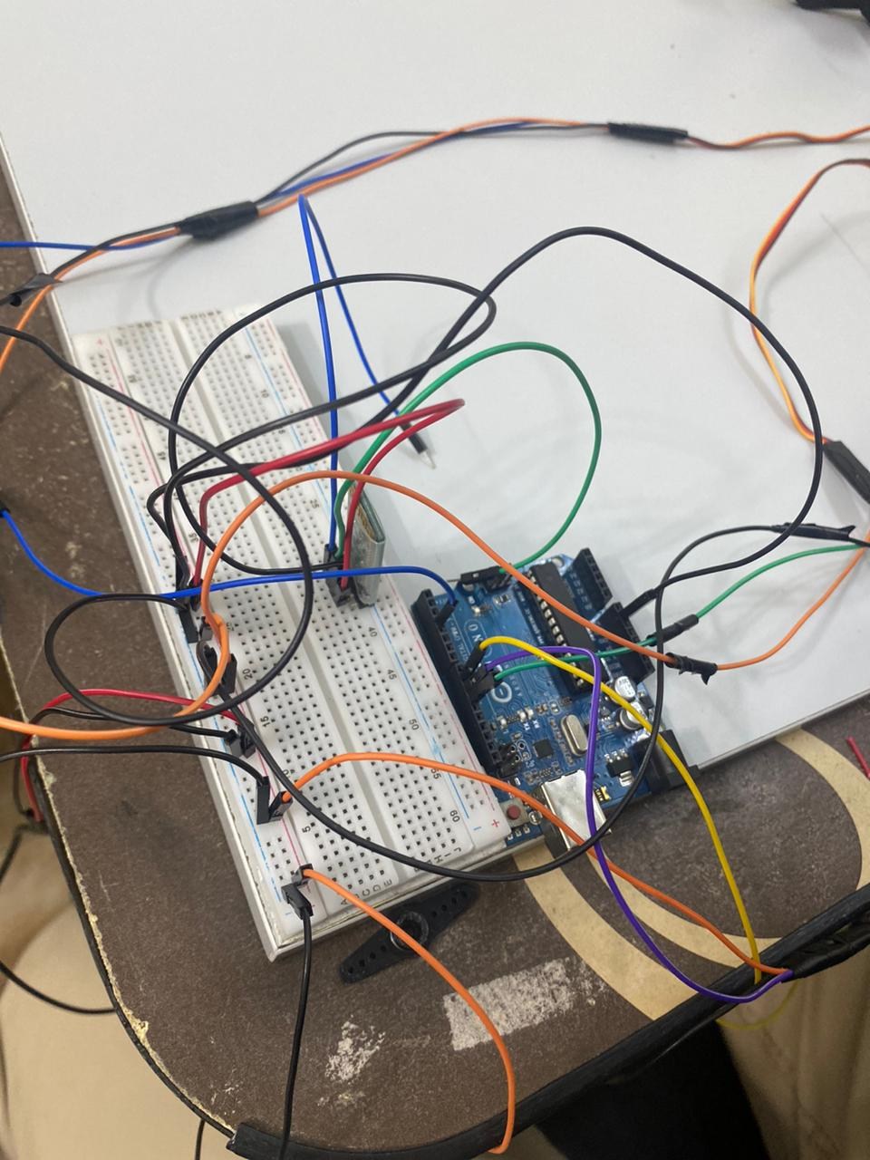

We also thought about controlling with a joystick and tested the code.

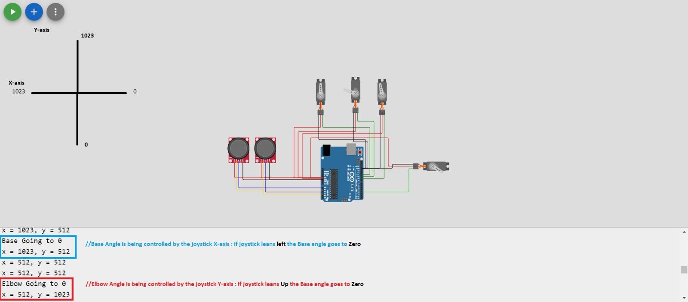

* **Reference and data**:

Our drive material link :

https://drive.google.com/drive/folders/1lXua5VC44EhLREbT7qsgFk3L_IUIcIIN?usp=drive_link